|  |  |  |
| --- | --- | --- |
| **Course Name**: Information and Communication Technologies Lab | | |
| **Lab # 6:** Arduino IDE and C Programming | | |
| **Department** | **Registration Number/Name** | **Semester/Section** |
| BS CEN | F24604018/Muhammad Hamzah Iqbal | 1 |
| **Date** | **Instructor’s Name** | **Instructor’s Signature** |
| 17/10/2024 | Iqra Ashraf |  |

Objectives:

* To understand the interfacing of Arduino
* To write the Arduino Program on Arduino IDE.
* Blink an LED using IDE and Arduino Board

**Task:**

Using Thinker CAD, blink 6 LEDs with 1 switch on Arduino.

**Code:**

* To turn on the LEDs, we connected each LED to a specific digital pin on the Arduino board.
* Then, we went to the code section to write the program.
* We started with a "forever" loop to keep the circuit running until stop simulation is clicked.
* To turn each LED on, we used the "set pin (number) to HIGH" block.
* To show the transition from OFF to ON, we added a "wait 1 second" block.
* After that, we used the "set pin (number) to LOW" block to turn off each LED.
* Then we added another "wait for 1 second" block to show the transition from ON to OFF.
* Finally, we started the simulation to see the LEDs light up and turn off as expected.

**Output:**

LEDs OFF:

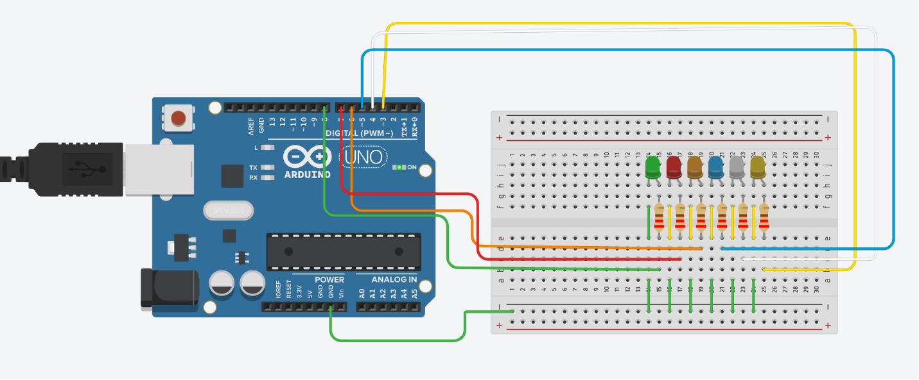

LEDs ON:

**Conclusion:**

In this lab, we successfully learned how to use Tinker cad for designing circuits. We also learned how to build circuits and control them with code according to our needs in Tinker cad. This has helped us better understand how to use simulation tools for electronics projects.